UNIT-I 

UNIT-II 

UNIT - III
STEVE JOBS
Steve Jobs (1955-2011) was a co-founder of Apple Inc. and a key figure in the development of the personal computer industry, known for his visionary approach. Jobs played a crucial role in the creation of iconic products like the Macintosh, iPod, iPhone and iPad. His emphasis on design and user experience revolutionized the tech industry. Despite facing setbacks, Jobs returned to Apple in 1997 and led the company to remarkable success. His legacy extends beyond technology, impacting industries such as animation (PIXAR) and (iTunes).

After leaving Apple in 1985, Steve Jobs faced significant struggles. He founded NeXT computer a company aimed at creating high-end workstations, but it faced challenged in the competitive market. The NeXT computer did not achieve widespread success and the company shifted its focus to software development.

In 1986, Jobs also acquired the Graphics Group (Pixar) from Lucas film, while Pixar initially struggled to find a profitable business model, it eventually became a major plays in animation, creating ground breaking films like Toy Story. Despite these ventures, financial difficulties and product challenges continued to plague jobs. NeXT faced financial loans and PIXAR struggled to turn a profit. Jobs return to prominence came in 1996 when Apple acquired NeXt , leading to his eventual return to Apple in 1997

These struggles, however, played a crucial role in shaping Jobs resilience and strategic thinking, contributing to his later success at Apple.

Although Jobs had little involvement in the engineering and technical sides as a CEO he directly involved himself in product design. One patent was issued the day before he died; many more were issued after his death. Even when he was in hospital he sketched new designs that would hold the iPad in a hospital bed and also would oxygen monitor own his finger for simplicity.

In 2003, Jobs diagnosed with a neuroendocrine tumour in the pancreas. Though it was initially treated, he reported a hormone imbalance, underwent a liver transplant in 2009, but his health slowly declined. He died of respiratory arrest related to his metastatic tumour on 5th October,2011.

UNIT - IV 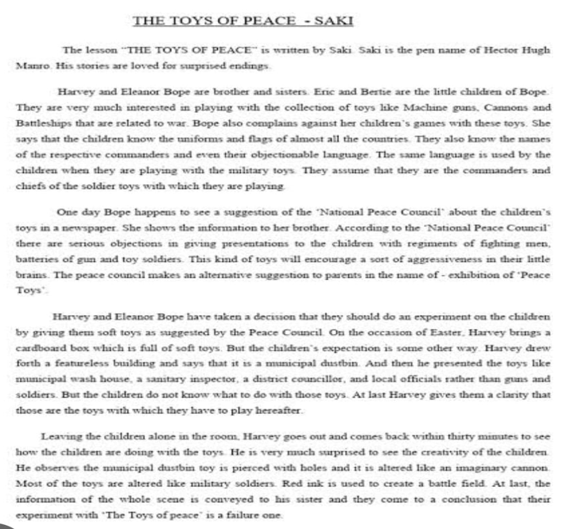

UNIT - IV



UNIT - V
THE POWER OF INTRAPERSONAL COMMUNICATION
Communication can be defined as the exchange of ideas, information and opinions between people. However, it also significantly exists within a person’s own mind. This form of communication is known as intrapersonal communication. It refers to the internal dialogue or self talk that occurs within an individual. It involves the thoughts, feelings and reflections a person has with themselves.
SELF-CONCEPTUALISATION: - is the process of forming and developing one’s self-concept - the way individuals perceive and understand themselves. It involves introspection, self-reflection and the integration of various aspects such as beliefs, values, abilities and experiences to create a coherent sense of identity.
EMOTIONAL REGULATION AND INTRAPERSONAL COMMUNICATION; - are inter connected aspects of individuals well-being. Intrapersonal communication plays a role in self-awareness, helping individuals recognize and understand their emotions. Emotional regulations involves managing and responding to these emotions effectively. Developing strong intrapersonal communication skills can enhance emotional regulation by fostering a deeper understanding of one’s feelings and promoting healthier coping strategies.
INTRAPERSONAL COMMUNICATION AND DECISION MAKING:-
Intrapersonal communication significantly impacts the way we make decisions.
CRITICAL THINKING:- This process involves engaging in internal debates, considering pros and cons, before arriving at a decision.
VALUE ALLIGNMENT:- Through self-talk we can align our decision with our values. This helps us to sustain our perspective and take actions based on our world view.
GOAL- SETTIING:- Intrapersonal communication helps us to set and pursue goals. We often have inner dialogues about our aspirations, motivating ourselves to achieve them.
INTRAPERSONAL COMMUNICATION AND PERSONAL GROWTH:
Intrapersonal communication is integral to personal growth as it involves self-reflection, self-awareness and understanding one’s thought and emotions.

Intrapersonal communication and well-being:- Intrapersonal communication impacts well-being by influencing self-perception and emotional regulation. It helps to
1. Reduces negative self-talk
2. Enhances self-confidence
3. Boosting confidence

Thus, developing strong intrapersonal communication skills is a valuable component of overall well-being.
CULTIVATING EFFECTIVE INTERPERSONAL COMMUNICATION; -
To harness the power of intrapersonal communication for personal growth, emotional regulation and well-being we can use the following strategies to cultivate effective interpersonal communication skills.
1) Mindfulness: Practicing mindfulness can increase awareness of one’s thoughts and emotions.
2) Journaling: Keeping a journal or diary on daily basis can provide an outlet for self-reflection.
3)Meditation: It helps to enhance emotional regulation, reduce stress and promote a calm and focused internal dialogue.
4) Positive Affirmation: Inculcating positive affirmation in one’s daily life can boost self-esteem.
CONCLUSION:
Interpersonal communication is a powerful in recognizing the importance of this internal dialogue which can help individuals to harness its power for personal and emotional growth leading to a more fulfilled and balanced life.

